**Case Study 5 – Spark Streaming Case Study**

**TASK 1:**

**First Part -** You have to create a Spark Application which streams data from a file on local directory on your machine and does the word count on the fly. The word should be done by the spark application in such a way that as soon as you drop the file in your local directory, your spark application should immediately do the word count for you.

The word count should done by spark application in such a way that as soon as we drop a file in that local directory, our spark-application should immediately do the word count of that file.

Below is the spark program to do the same.

*import org.apache.spark.{SparkConf, SparkContext}*

*import org.apache.spark.streaming.{Seconds,*

*StreamingContext} import org.apache.log4j.{Level,Logger}*

*object SparkFileStreamingWordCount*

*{*

*def main(args: Array[String]): Unit = {*

*println("hey Spark Streaming")*

*val conf = new SparkConf().setMaster("local[2]").setAppName("SparkSteamingExample")*

*val sc = new SparkContext(conf)*

*val rootLogger =Logger.getRootLogger()*

*rootLogger.setLevel(Level.ERROR)*

*// Create Streaming context to set batch duration 5 seconds*

*val ssc = new StreamingContext(sc, Seconds(5))*

*//Create RDD for text file streaming by*

*val lines = ssc.textFileStream("/home/acadgild/Desktop/Spark_Streaming")*

*//Split each line into words*

*val words = lines.flatMap(_.split(" "))*

*//Count each word in each batch*

*val wordCounts = words.map(x => (x, 1)).reduceByKey(_ + _)*

*wordCounts.print()*

*//Start the computation*

*ssc.start()*

*//wait for the computation to terminate*

*ssc.awaitTermination()*

*}*

*}*

Create the project in the Eclipse IDE and add the required Spark jars to the project build path as follows.

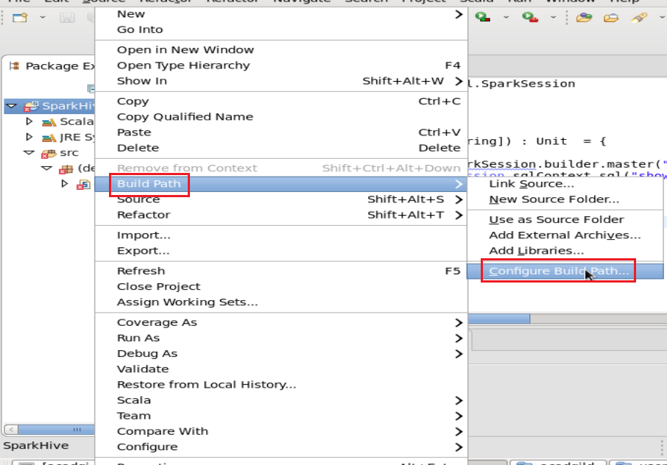



To add required jars, right click on the Project in Package Explorer, got to Build Path -> Configure Build Path…

Navigate to the jars location of Spark($SPARK_HOME/jars) and select all the jars into the build path. Click on Apply and Close. The Project is built and all the errors are removed from the code.

Let us create a directory Spark_Streaming in the Desktop folder of home acadgild directory by using following command:

*cd Desktop*

*mkdir Spark_Streaming*

The application in Eclipse is run.



In below screenshot we are able to see that spark streaming is running every 5 seconds.



Now we put a blank text file ’match’ and then putting some words in this file.



Output of word count in console:



**TASK 2:**

**Second Part - In this part, you will have to create a Spark Application which should do the following**

**1. Pick up a file from the local directory and do the word count**

**2. Then in the same Spark Application, write the code to put the same file on HDFS.**

**3. Then in same Spark Application, do word count of the file copied on HDFS in step 2.**

**4. Lastly, compare the word count of step 1 and 2. Both should match, other throw an error**

The spark program for the above requirement is below.

*import java.io.File*

*import org.apache.spark.{SparkConf, SparkContext}*

*import scala.io.Source._*

*import org.apache.log4j.{Level,Logger}*

*object SparkHDFSWordCountComparison*

*{*

*// defining the local file directory*

*private var localFilePath: File = new File("/home/acadgild/Desktop/Spark_Streaming/text")*

*//defining the directory in hdfs path*

*private var dfsDirPath: String = "hdfs://localhost:8020/user"*

*private val NPARAMS = 2*

*def main(args: Array[String]): Unit = {*

*//parseArgs(args)*

*println("SparkHDFSWordCountComparison : Main Called Successfully")*

*println("Performing local word count")*

*//read the file which is present in local directory and convert into string*

*val fileContents = readFile(localFilePath.toString())*

*println("Performing local word count - File Content ->>"+fileContents)*

*val localWordCount = runLocalWordCount(fileContents)*

*println("SparkHDFSWordCountComparison : Main Called Successfully -> Local Word Count is*

*- >>" +localWordCount)*

*println("Performing local word count Completed !!")*

*println("Creating Spark Context")*

*//Create spark context*

*val conf = new SparkConf().setMaster("local[2]").setAppName("SparkHDFSWordCountComparisonApp")*

*val sc = new SparkContext(conf)*

*// Setting log level to [WARN] for streaming executions and to override add a custom log4j.properties to the*

*//classpath*

*val rootLogger =Logger.getRootLogger()*

*rootLogger.setLevel(Level.ERROR)*

*println("Spark Context Created")*

*println("Writing local file to DFS")*

*val dfsFilename = dfsDirPath + "/dfs_read_write_test"*

*val fileRDD = sc.parallelize(fileContents)*

*fileRDD.saveAsTextFile(dfsFilename)*

*println("Writing local file to DFS Completed")*

*println("Reading file from DFS and running Word Count")*

*val readFileRDD = sc.textFile(dfsFilename)*

*val dfsWordCount = readFileRDD*

*.flatMap(_.split(" "))*

*.flatMap(_.split("\t"))*

*.filter(_.nonEmpty)*

*.map(w => (w, 1))*

*.countByKey()*

*.values*

*.sum*

*sc.stop()*

*//apply if condition to check word count result from both the directories*

*if (localWordCount == dfsWordCount)*

*{*

*println(s"Success! Local Word Count ($localWordCount) " +*

*s"and DFS Word Count ($dfsWordCount) agree.")*

*}*

*else {*

*println(s"Failure! Local Word Count ($localWordCount) "*

*+ s"and DFS Word Count ($dfsWordCount) disagree.")*

*}*

*}*

*/***private def parseArgs(args: Array[String]): Unit =*

*{ if (args.length != NPARAMS) {*

*printUsage()*

*System.exit(1)*

*}*

*}***/*

*private def printUsage(): Unit = {*

*val usage: String = "DFS Read-Write Test\n" +*

*"\n" +*

*"Usage: localFile dfsDir\n" +*

*"\n" +*

*"localFile - (string) local file to use in test\n" +*

*"dfsDir - (string) DFS directory for read/write tests\n"*

*println(usage)*

*}*

*private def readFile(filename: String): List[String] = {*

*val lineIter: Iterator[String] = fromFile(filename).getLines()*

*val lineList: List[String] = lineIter.toList*

*lineList*

*}*

*def runLocalWordCount(fileContents: List[String]): Int =*

*{*

*fileContents.flatMap(_.split(" "))*

*.flatMap(_.split("\t"))*

*.filter(_.nonEmpty)*

*.groupBy(w => w)*

*.mapValues(_.size)*

*.values*

*.sum*

*}*

*}*

Output of the second spark application:



Above screen shot shows that, word count of file from local file directory and HDFS directory file is same.

Output file in HDFS directory shown below in screen shot.



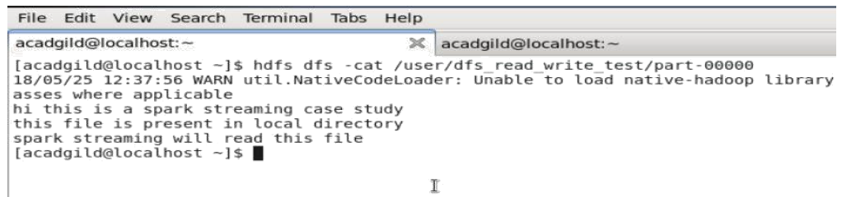

Above screen, shot shows the content of the output file part-00000 which same as the file present in the local directory.